Simulation of Exchanging Spin Systems

Matrix Formulation
A two-site exchanging system can be simulated by solving the combined Bloch equations:

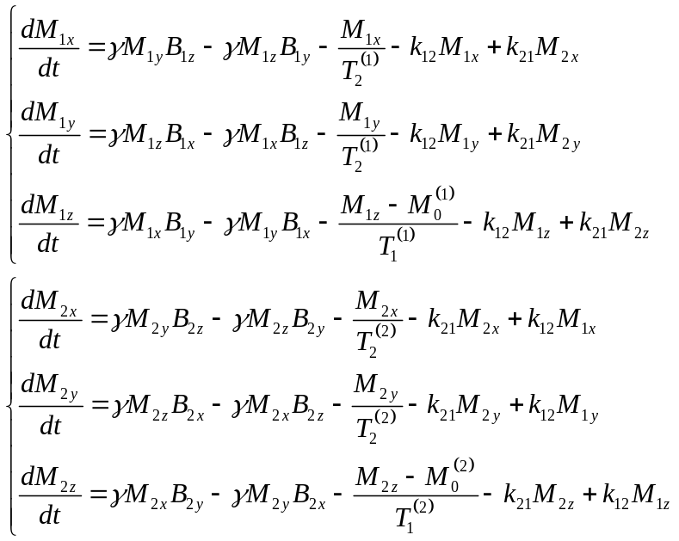

This can be recast using matrix notation:

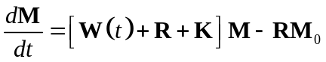.

Here

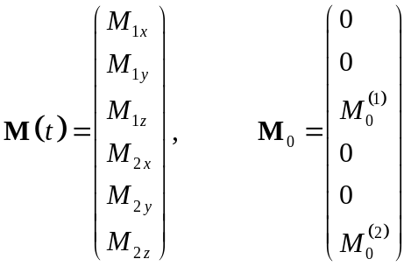.

W describes the effect of the external B field:

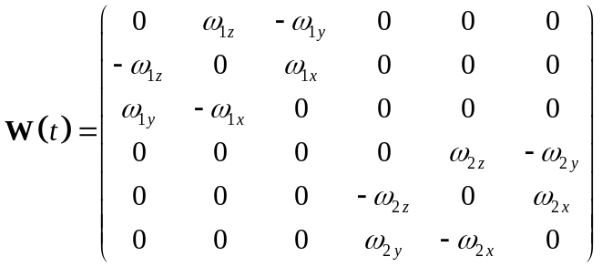.

R includes relaxation effects:

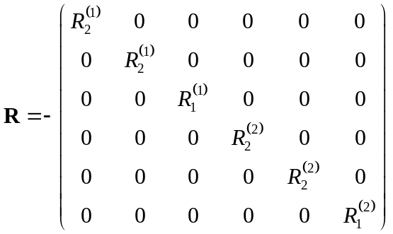

K describes the effects of the exchange:

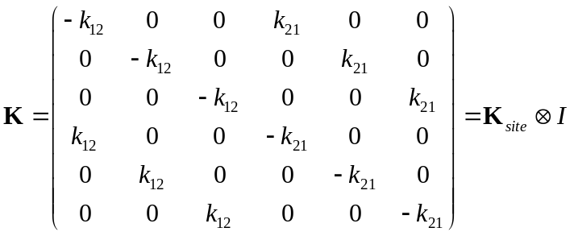

I is the 3×3 identity matrix of a single spin, and K_{site} is the chemical exchange kinetics matrix describing the transfer of magnetization between the two spins (“sites”):

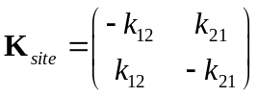.

A Matrix Solution
Equation can be solved via a change of variables and matrix exponentation. First, substitute 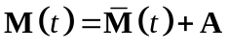, where A is a time constant:

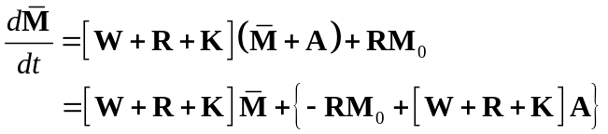

Choose:

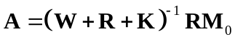, (matrix inversion!)

so

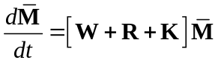.

If W is constant in time, we can solve this via matlab exponentiation:

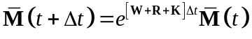

and then transform back:

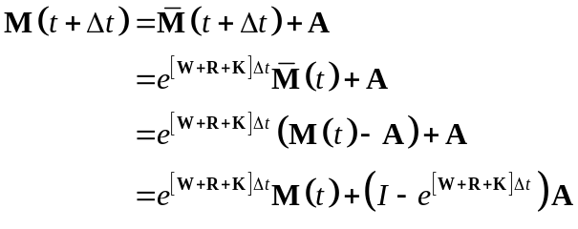

Substituting A:

.

Simulating Pulse Offsets
An offset Δν can be added to any complex pulse waveform B(t) via

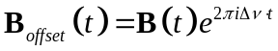.

Although pulse offsets can be simulated by breaking down a pulse down to sub-steps small enough to capture the time dependence (Δt<<1/Δν), a more efficient approach would be to transform to a system which rotates with Δν and then transform back again. Starting from Eq. , we substitute

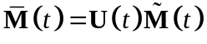,

where U represents a constant rotation of the system (UU^{T}=I) around the z-axis, so:

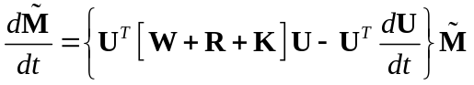.

How would a “typical” U look like? For a single spin, U is just a rotation matrix about z:

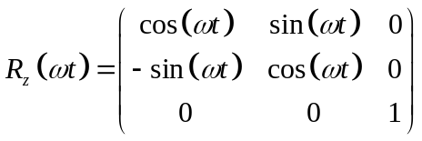.

For a 2-spin exchanging system, this needs to be extended:

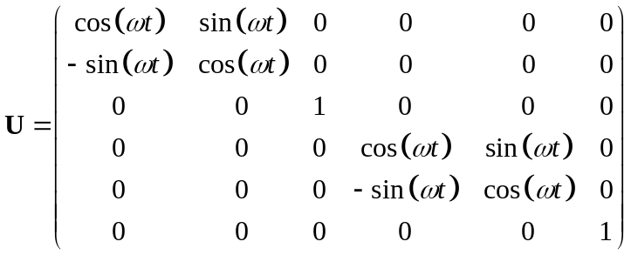.

As a result,

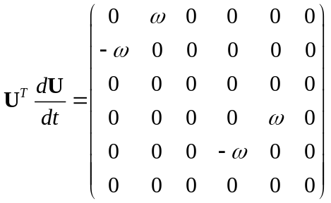.

Furthermore, it is possible to show via brute force that

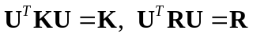.

Finally, the matrix U^{T}WU merely represents the “transformed RF field”, which is simply the RF field without the offset (and whatever chemical shifts there are, which appear as non-zero z-components of the field and are unaffected by a rotation around z). Thus, we need to solve:

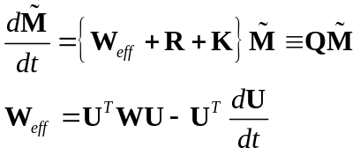

where W_{eff} is the effective field. This is as straightforward as simply substituting W_{eff} for W in the exponent in Eq. (note, however, one should not make this substitution when calculating A in Eq. ).
Transforming back, we obtain:

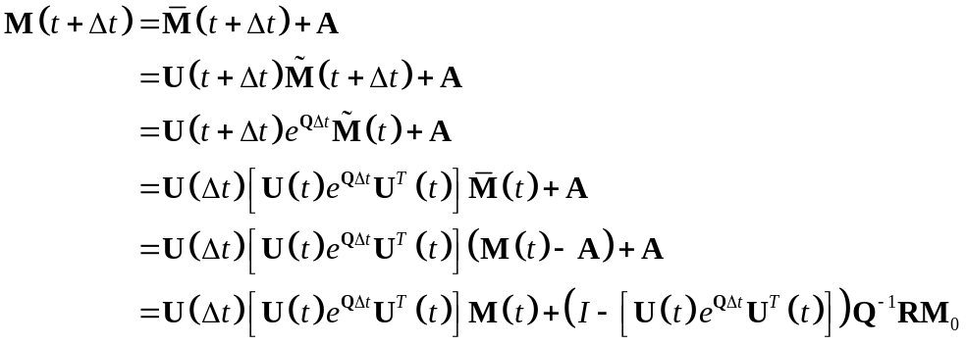

I am assuming here the same transformation (“rotating frame”) is applied to both sites. This makes sense if we are dealing with a homonuclear system, but not for a heteronuclear system. However, for a heteronuclear system, U^{T}KU is time dependent! Therefore, we remain at the homonuclear level.

